Problem-1 "A farmer has a 100 acre farm. He can sell all tomatoes, lettuce or radishes and can raise the price to obtain Rs.1.00 per kg. for tomatoes , Rs.0.75 a head for lettuce and Rs.2.00 per kg for radishes. The average yield per acre is 2000kg.of tomatoes, 3000 heads of lettuce and 1000 kgs of radishes. Fertilizers are available at Rs.0.50 per kg and the amount required per acre is 100 kgs for each tomatoes and lettuce and 50kgs for radishes. Labour required for sowing, cultivating and harvesting per acre is 5 man-days for tomatoes and radishes and 6 man-days for lettuce. A total of 400 man-days of labour are available at Rs.20.00 per man-day. Formulate this problem as LP model to maximize the farmers profit."
Solution:
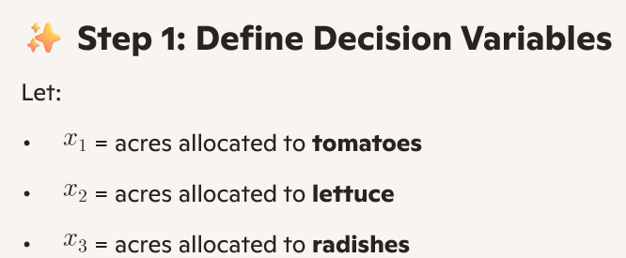
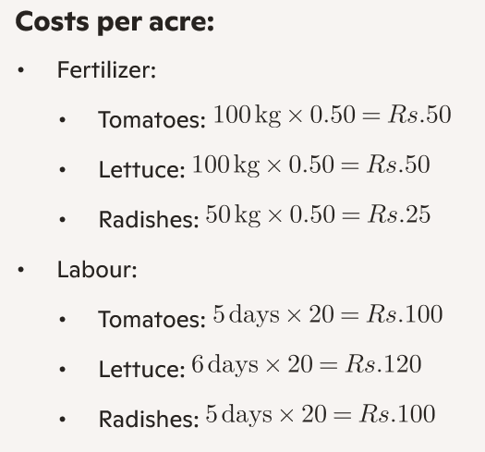
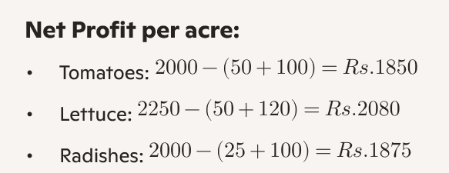
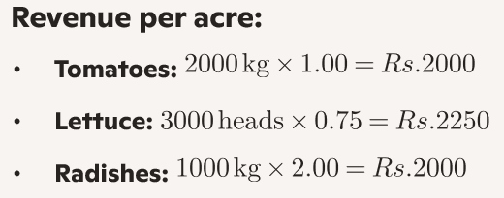

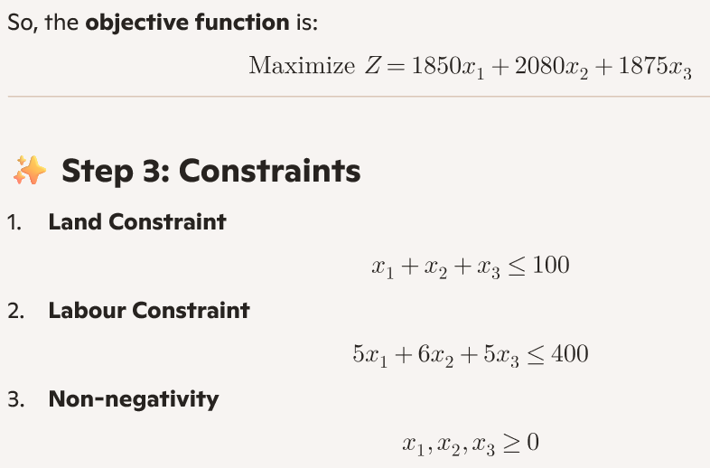

Problem 2:
"A firm manufactures Headache pills in two sizes: size A and size B. Size A contains 2 grams of Aspirin, 5 grams of Bicarbonte, 1 gram of Codine Size B contains 1 gram of Aspirin, 8 grams of Bicarbonte, 6 grams of Codine It is found that it requires atleast 12 grams of Aspirin 74 grams of Bicarbonte, 24 grams of Codine for immediate effect. It is required to determine the least number of pills a patient should take to gat immediate relief. Formulate the problem as LPP ?
Solution
x1 = number of Size A pills taken and x2 = number of Size B pills taken

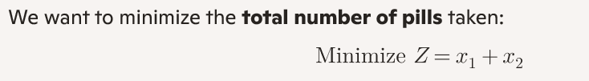
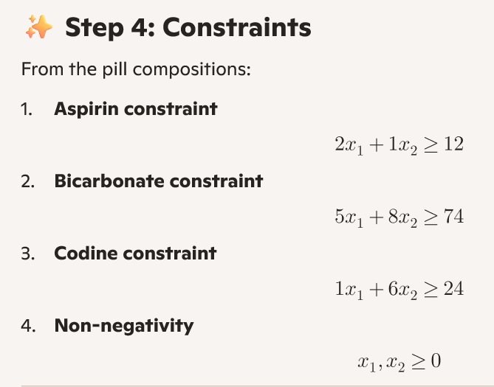
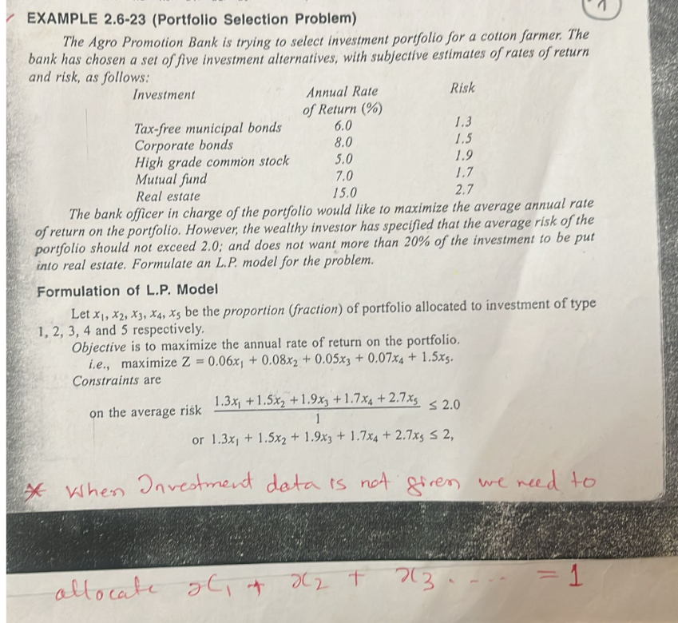

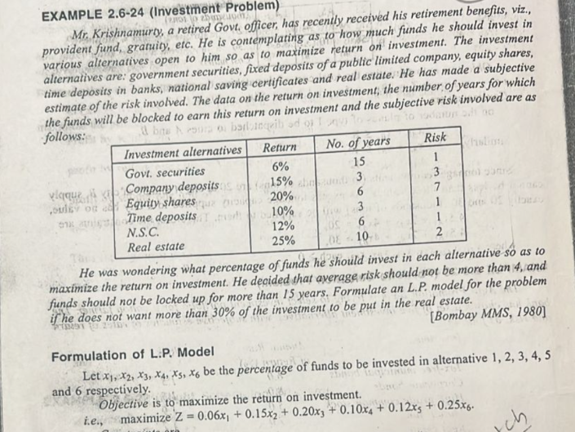
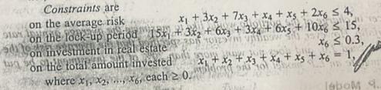

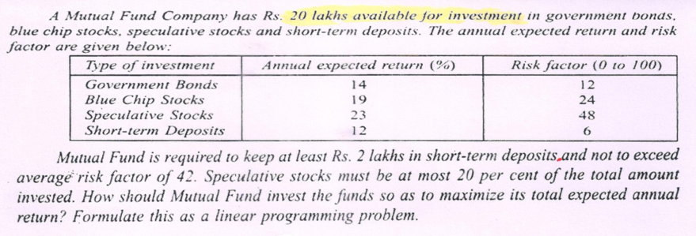

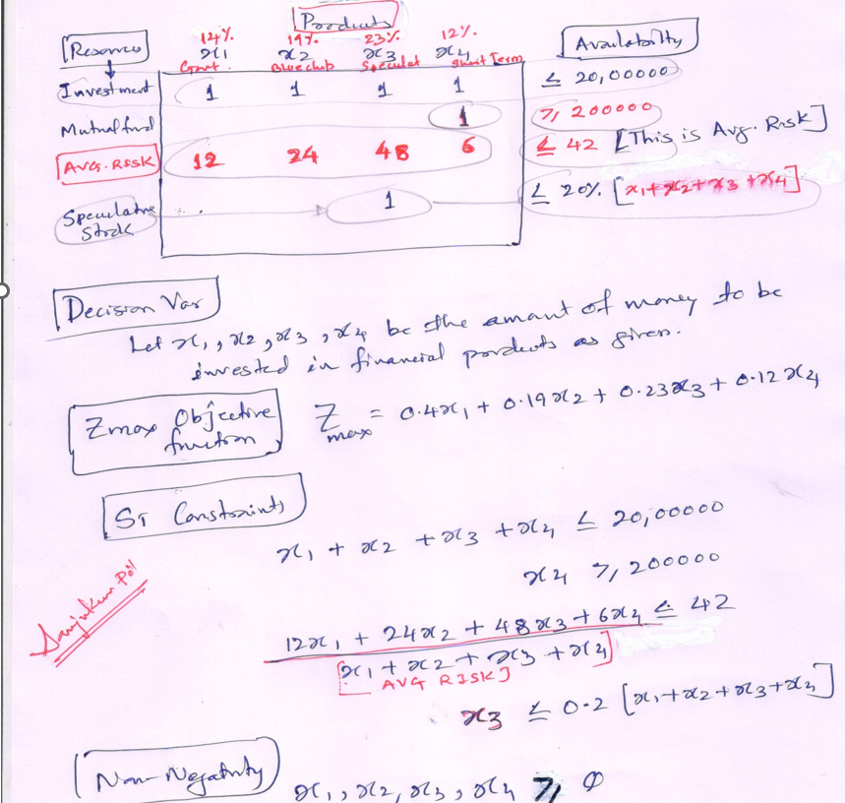

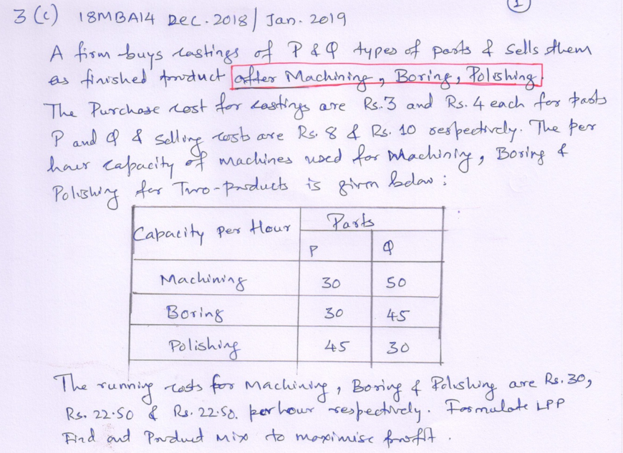

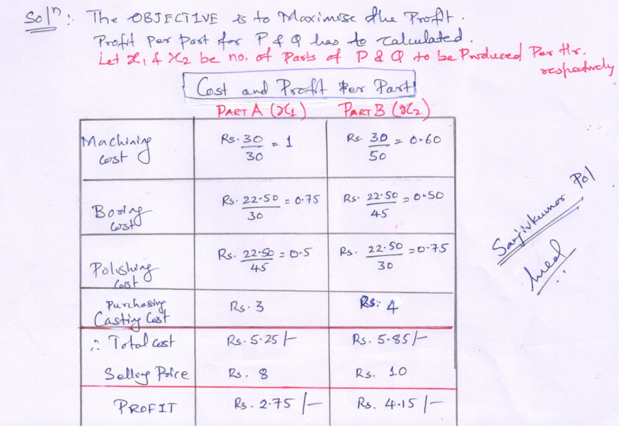
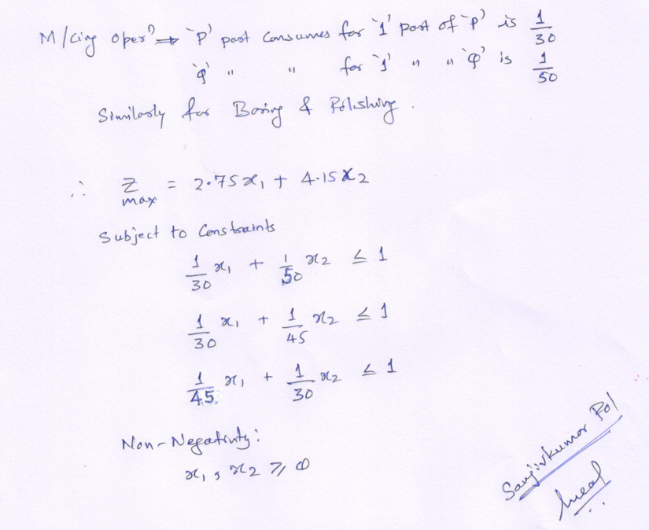

Similar to Above one more for practice

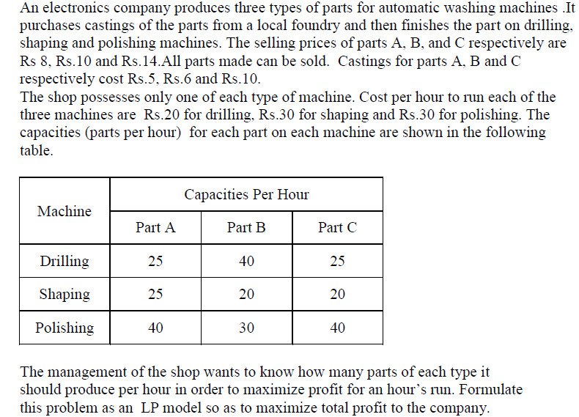

SOLUTION:

Part A Should undergo DRILLING, SHAPING AND POLISHING… Same with B and C

PART A PROFIT = 8 – (5 + COST of DRIL + COST of Shape + COST of Polish)

same with B & C…… as per their respective given Prices.

Part A = 8 – ( 5 + (Rs. 20 per hr drilling divide by 25 parts per hr )
+
(Rs. 30 per hr shaping divide by 25 parts per hr )
+
(Rs. 30 per hr polishing divide by 40 parts per hr )

Part A = 8 – ( 5 + 0.8 + 1.2 + 0.75) = 0.25 per piece of Part A

Similarly Solve for PART B & PART C
Calculate for Part B (1.0) and part C (0.95)

Decision variable
Let X1 and X2 and X3 be the number of types A, B and C parts produced per hour
respectively .

Objective function
Maximize Z = 0.25 X1 + 1X2 + 0.95X3

PER PART BASIS WE NEED TO ALLOCATE
Constraints are capacity per hour given for parts….

RESOURCE | Part A X1  Per Part | Part B X2  Per Part | Part C X3  Per Part | CAPACITY
DRILLING | X1/25 | X2/40 | X3/25 | < = 1
SHAPING | X1/25 | X2/20 | X3/20 | < = 1
POLISHING | X 1/40 | X2/30 | X3/40 | < = 1

Non-Negativity ===== Where X1, X2, X3 ≥ 0

